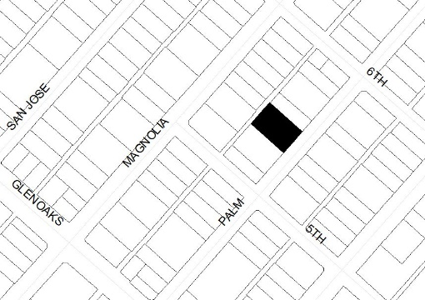  Public Notice  Proposed Multi-Family Residential Condominium Development Located at 529-537 E. Palm Ave.  What is this?  You’re invited to attend a Community Meeting to discuss a Development Review (DR) application that proposes to demolish the existing residential units at the Project site to construct a new four-story 24-unit housing development. A Tentative Tract Map – Condominium Map is requested by the Project Applicant to combine the two parcels and construct the residential condominium units. The residential parking would be provided in a subterranean-level parking garage (total of 38 proposed parking spaces). In addition, the project requests a 50% density bonus and the Project Applicant intends to use several waivers and reduced parking standards as allowed by the State and City’s Density Bonus regulations. The Project site is currently zoned R-4 (High Density Residential). The Development Review and Tentative Tract Map – Condo Map is requested by the Project Applicant in accordance with the Burbank Municipal Code Title 10 (Zoning Regulations) and Title 11 (Subdivisions).  The City is currently preparing an environmental assessment for the Project. The City has determined that the Project may be eligible for an exemption from the California Environmental Quality Act (CEQA) under CEQA Guidelines Section 15332 (In-fill Development Projects).  Why am I receiving this Notice?  You are getting this notice because the Project is located near where you live or own property. This notice was mailed to all residents and property owners within 1,000 feet of the Project Site. You can call or write to tell us what you think about the Project prior to, or during the Community Meeting per the instructions below. The City of Burbank Community Development Director will review the Project and make a decision on whether to approve or deny the Project at a future decision date following the Community Meeting.  How do I find out more or participate?  Call the project planner, David Kim, at (818) 238-5250  E-mail the project planner at: DKim@burbankca.gov  View documents related to this project online at:  www.burbankca.gov/pendingprojects  Attend the Community Meeting to discuss the project on Thursday, February 16, 2023, at 6:00 p.m. The meeting will be held in the Community Services Building, Room 104, located at 150 N. Third Street in Burbank.  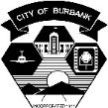  Date: February 2, 2023  Project: Planning Application No. 19-0005588  Burbank Planning Division - www.burbankca.gov/planning |  | 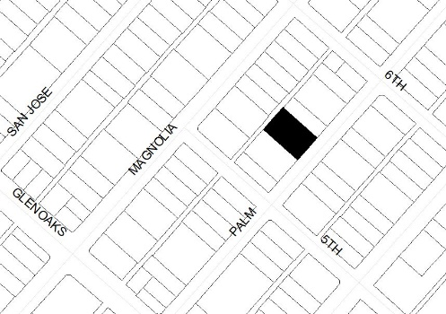  Public Notice  Proposed Multi-Family Residential Condominium Development Located at 529-537 E. Palm Ave.  What is this?  You’re invited to attend a Community Meeting to discuss a Development Review (DR) application that proposes to demolish the existing residential units at the Project site to construct a new four-story 24-unit housing development. A Tentative Tract Map – Condominium Map is requested by the Project Applicant to combine the two parcels and construct the residential condominium units. The residential parking would be provided in a subterranean-level parking garage (total of 38 proposed parking spaces). In addition, the project requests a 50% density bonus and the Project Applicant intends to use several waivers and reduced parking standards as allowed by the State and City’s Density Bonus regulations. The Project site is currently zoned R-4 (High Density Residential). The Development Review and Tentative Tract Map – Condo Map is requested by the Project Applicant in accordance with the Burbank Municipal Code Title 10 (Zoning Regulations) and Title 11 (Subdivisions).  The City is currently preparing an environmental assessment for the Project. The City has determined that the Project may be eligible for an exemption from the California Environmental Quality Act (CEQA) under CEQA Guidelines Section 15332 (In-fill Development Projects).  Why am I receiving this Notice?  You are getting this notice because the Project is located near where you live or own property. This notice was mailed to all residents and property owners within 1,000 feet of the Project Site. You can call or write to tell us what you think about the Project prior to, or during the Community Meeting per the instructions below. The City of Burbank Community Development Director will review the Project and make a decision on whether to approve or deny the Project at a future decision date following the Community Meeting.  How do I find out more or participate?  Call the project planner, David Kim, at (818) 238-5250  E-mail the project planner at: DKim@burbankca.gov  View documents related to this project online at:  www.burbankca.gov/pendingprojects  Attend the Community Meeting to discuss the project on Thursday, February 16, 2023, at 6:00 p.m. The meeting will be held in the Community Services Building, Room 104, located at 150 N. Third Street in Burbank.  Date: February 2, 2022  Project: Planning Application No. 19-0005588  Burbank Planning Division - www.burbankca.gov/planning

