Removed from Waiting List
SECTION 8 ELIGIBILITY FLOWCHART
Approved
Move to Second Phase
First Phase of Review
Preferences & Income
Applicant Randomly Selected from Waiting List
Pre-Application
Submitted

Waiting List
Denied for
Preference or Income-Targeting
Denied for
Over-income or Non-Compliance

BACK TO WAITLIST
INELIGIBLE

INELIGIBLE
OR

Second Phase of Review
Income and Eligibility Determination

Approved
Move to Voucher issuance
Denied for
Over-Income or Non-Compliance

Initial Interview for
Voucher Issuance

Voucher Expires

Housing Search
BACK TO HOUSING SEARCH

Unit Found

Participation Begins

Tenancy Approved

Pass Inspection

Schedule Initial Inspection
Unit Denied for High Rent, No Rent Comparables or Failed Inspection
Submit Request for Tenancy Approval (RFTA)
Final Eligibility Review

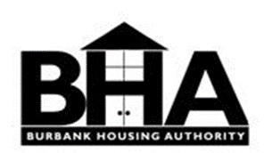

Revised August 2018

