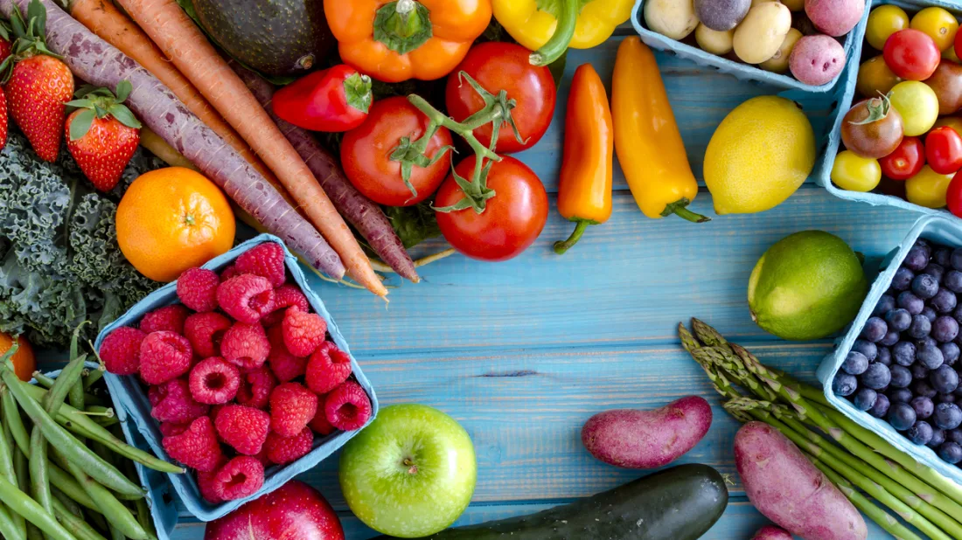
FREE NUTRITION EDUCATION WORKSHOPS

Get a Taste of Healthy Eating by joining the
CalFresh Healthy Living Eat Healthy, Be Active!
4-week Workshop Series.

Learn more about nutrition and physical activity
PLUS LIVE FOOD DEMONSTRATIONS.

FREE GIVEAWAYS FOR THOSE THAT ATTEND.
---------------------------------------------
Dates: Fridays - August 4th, 11th, 18th & 25th
Time: 11:00am – 12:00pm
Location: Add location and room if applicable.
TOPICS TAUGHT BY A REGISTERED DIETITIAN & INCLUDE:
Budget friendly eating tips.
How to prepare healthy, quick meals and snacks.
Ways to include exercise into your day.
Helpful food facts.

Limited Spaces Available. Sign up today!
To sign up contact (Add NAME and NUMBER)
or email CFHL@foodsafe.com
You can also sign up (Add where they would sign up at site.)

Virtual classes also available. For more information email CFHL@foodsafe.com

