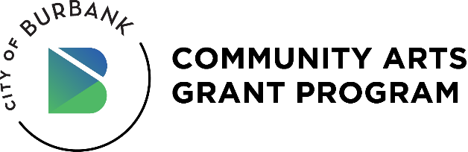

**VENUE – LETTER OF INTENT**

The City of Burbank Community Arts Grant Program requires grant applicants to provide proposed dates and locations of project activities. Applicants are encouraged to identify and engage with proposed venues in the preparation of this application. While a venue letter of intent is optional, it is highly recommended. Complete, sign, and include as a PDF attachment to the submitted grant application. You may use this template or you may include the same information in an email or on venue letterhead.

**APPLICANT**

**Name of Applicant:**

**PROPOSED VENUE/LOCATION**

**Venue Name:**

**Venue Address:**

**Contact Name:**

**Telephone Number:**

**Email Address:**

**Special Use Requirements (optional):**

**Preliminary Prices Quoted for Rental Fees (if applicable):**

**Signature of Venue Representative:**

All events must take place in an ADA-compliant building, facility, or outdoor space located in the City of Burbank (91501, 91502, 91503, 91504, 91505, 91506, 91507, 91508, 91510, 91521, 91522, 91523, 91526). The venue and producer must obey all occupancy, safety, and health regulations from the City of Burbank, County of Los Angeles, and State of California.

This Letter of Intent form is only to provide information for the grant review process and confirm the grantee is in discussion with the venue. Grantee will be responsible for the venue contract. Applicants and venue operators are strongly urged to develop a mutual agreement or contract.

UPLOAD THE SIGNED FORM AS PART OF YOUR GRANT APPLICATION.  
Questions: [communityartsgrant@burbankca.gov](mailto:communityartsgrant@burbankca.gov)